**HO CHI MINH UNIVERSITY OF TECHNOLOGY  
DEPARTMENT OF ELECTRONICS**



**LAB 2 REPORT**

**SUBJECT: LOGIC SYNTHESIS (EE4449)  
CLASS: TT01  
SEMESTER: 231**

**INSTRUCTOR: Mr. NGUYỄN TUẤN HÙNG**

**STUDENT NAME: NGUYỄN TRƯỜNG PHÚ  
STUDENT ID: 2051058**

**TASK:**

Solve the matrix equation:

Y(24-bit) = A(8-bit) * B(8-bit) + C(16-bit)

Where **A** is a 128x128 matrix containing 8-bit integers, **B** is a 128x1 column vector containing 8-bit integers, **C** is a 128x1 column vector containing 16-bit integers, and **Y** is a 128x1 column vector containing 24-bit integers. You should treat all values stored in the matrixes as unsigned integers, but keep in mind that they have different widths (as is typical for matrix-accumulation operations). These widths are chosen such that the intermediate products **should not have any loss of precision.**

In the handout files, we’ll provide you **A**, **B**, and **C**, all of which are static. You will include **A**, **B**, and **C** in your design by downloading them onto the board at configuration time, but your implementation should work with arbitrary matrices of the same shapes. Your system will perform the MAC calculation, but rather than have a complicated UI to view each element of the resulting matrix (**Y**), *your system will simply sum up all the values in the* ***Y*** *matrix and display the resulting 24-bit sum*.

To make this easier to grade, you are to show two different values in the hex displays. **SW0** will be used to determine what to show. If the switch is 1'b0, the hex display shows the 24-bit result of the calculation (encoded as 6 hex numerals). If the switch is 1'b1, the hex display will show the number of clock ticks (in hex) needed to execute the computation.

**CODES:**

Using the seven provided files, I have used Terasic DE10 System Builder to create an entire new project named ***MATMUL.qpf***, for my convenience.

Alongside those seven files, I have coded 25 more SystemVerilog files, all of which are included along with this report:

**1. MATMUL.sdc**: Synopsys Design Contraints for DE10’s built-in 50 MHz clock, as requested by the Lab.

**2. DFFF.sv**: A falling-edge D flip-flop, for the Edge Enforcer below.

**3. edge_enforcer.sv**: A circuit to guarantee that the starting clock signal (aka. right after rising edge of RESET) is always LOW.

**4, 5, 6. counter_for_A.sv; counter_for_B.sv; counter_for_C.sv**: Three separate counters for three ROMs. In order to achieve 4000 clock cycles, counter A and B are designed to fetch 4 addresses in one go.

**7. switch16.sv**: a circuit to switch on and off a 16-bit output.

**8. romC_128x1_T.sv**: connect the above switch to ROM C, the switch signal will be controlled by **counter_for_C**.

**9, 10, 11. adder16.sv; adder17.sv; adder18.sv**: Three adders with three diffferent bit widths to fit in different places.

**12, 13, 14, 15. reg16.sv; reg17.sv; reg18.sv; reg19.sv**: Four different registers with four different bit widths to fit in different places.

**16. MUL_BLOCK.sv**: The main circuit to perform

*AnBn + An+1Bn+1 + An+2Bn+2 + An+3Bn+3*

**17, 18, 19. adder32.sv; reg32.sv; acc32.sv**: 32-bit adders and registers, together forming the accumulator, to add up the sums of the above operation and the elements from ROM C.

**20, 21, 22. binto7seg.sv; segsel.sv; segssel.sv**: Circuits for connecting to seven-segment displays.

**23. LABTWO.sv**: The second-top-level module, putting all above files together, then hook inputs and outputs to corresponding peripherals.

**24**. **TB.sv**: Test bench for LABTWO to connect to third-party simulators.

**25. MATMUL.sv**: The actual top-level module, wrapper of LABTWO.sv, connecting directly to DE10’s switches, buttons, and displays.

**RTL VIEW:**

The full-resolution image is provided as PDF alongside this report.

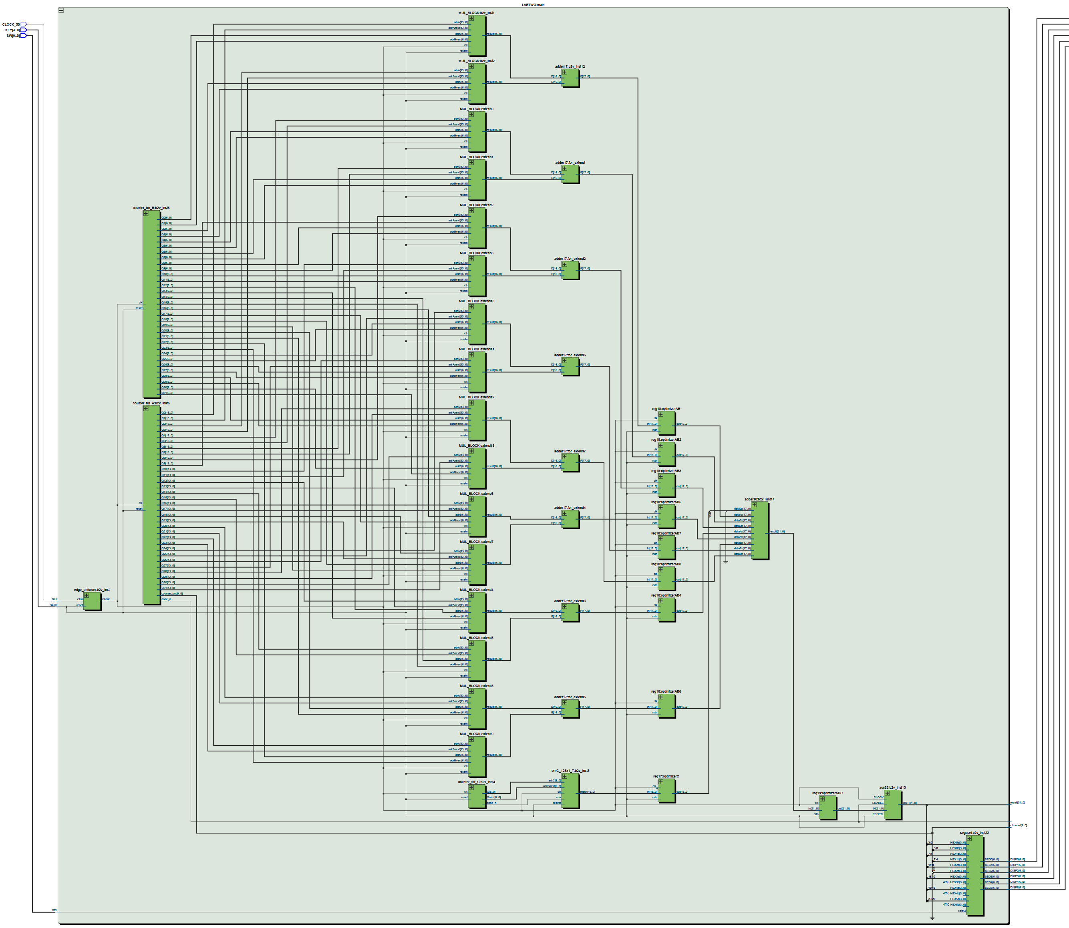  
*RTL circuit for MATMUL.sv*

**RESULT ON SIMULATION:**

Using **TB.sv** and ModelSim to simulate four test cases: two provided by the Lab, one random, and one maximum (i.e. ROM A and B filled with FF16 and ROM C with FFFF16).

I also need to compile **altera_mf.v** provided by the Lab in order to get the three ROMs to work.

*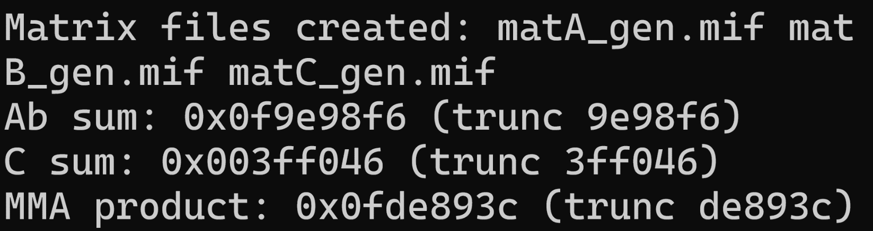  
Expected result for Case 3*

*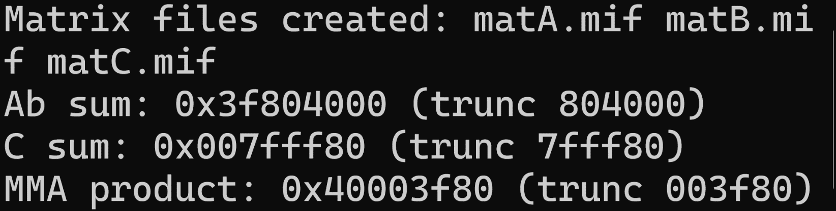  
Expected result for Case Max*

*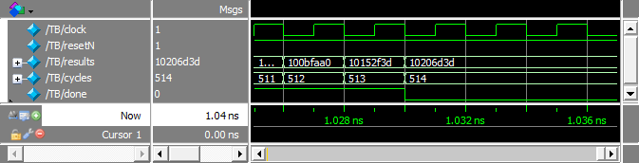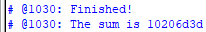  
Test Case #1 Passed, took 514 cycles*

*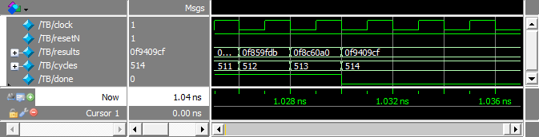  
Test Case #2 Passed*

*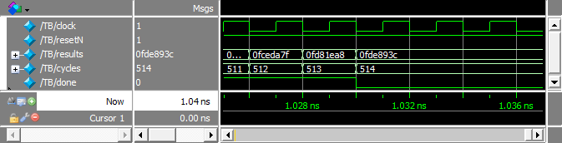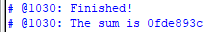  
Test Case #3 Passed*

*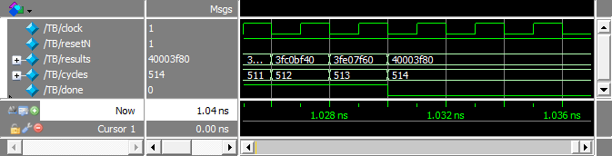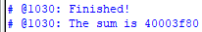  
Test Case Max Passed*

**RESULT ON DE10:**

Along with SW0 to toggle displays, I have also assigned KEY0 as an active-low RESET input. Demonstration videos for four cases above are also attached for submission.

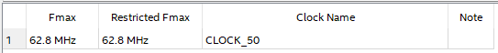  
*Fastest possible I can reach on my 514-clock design*

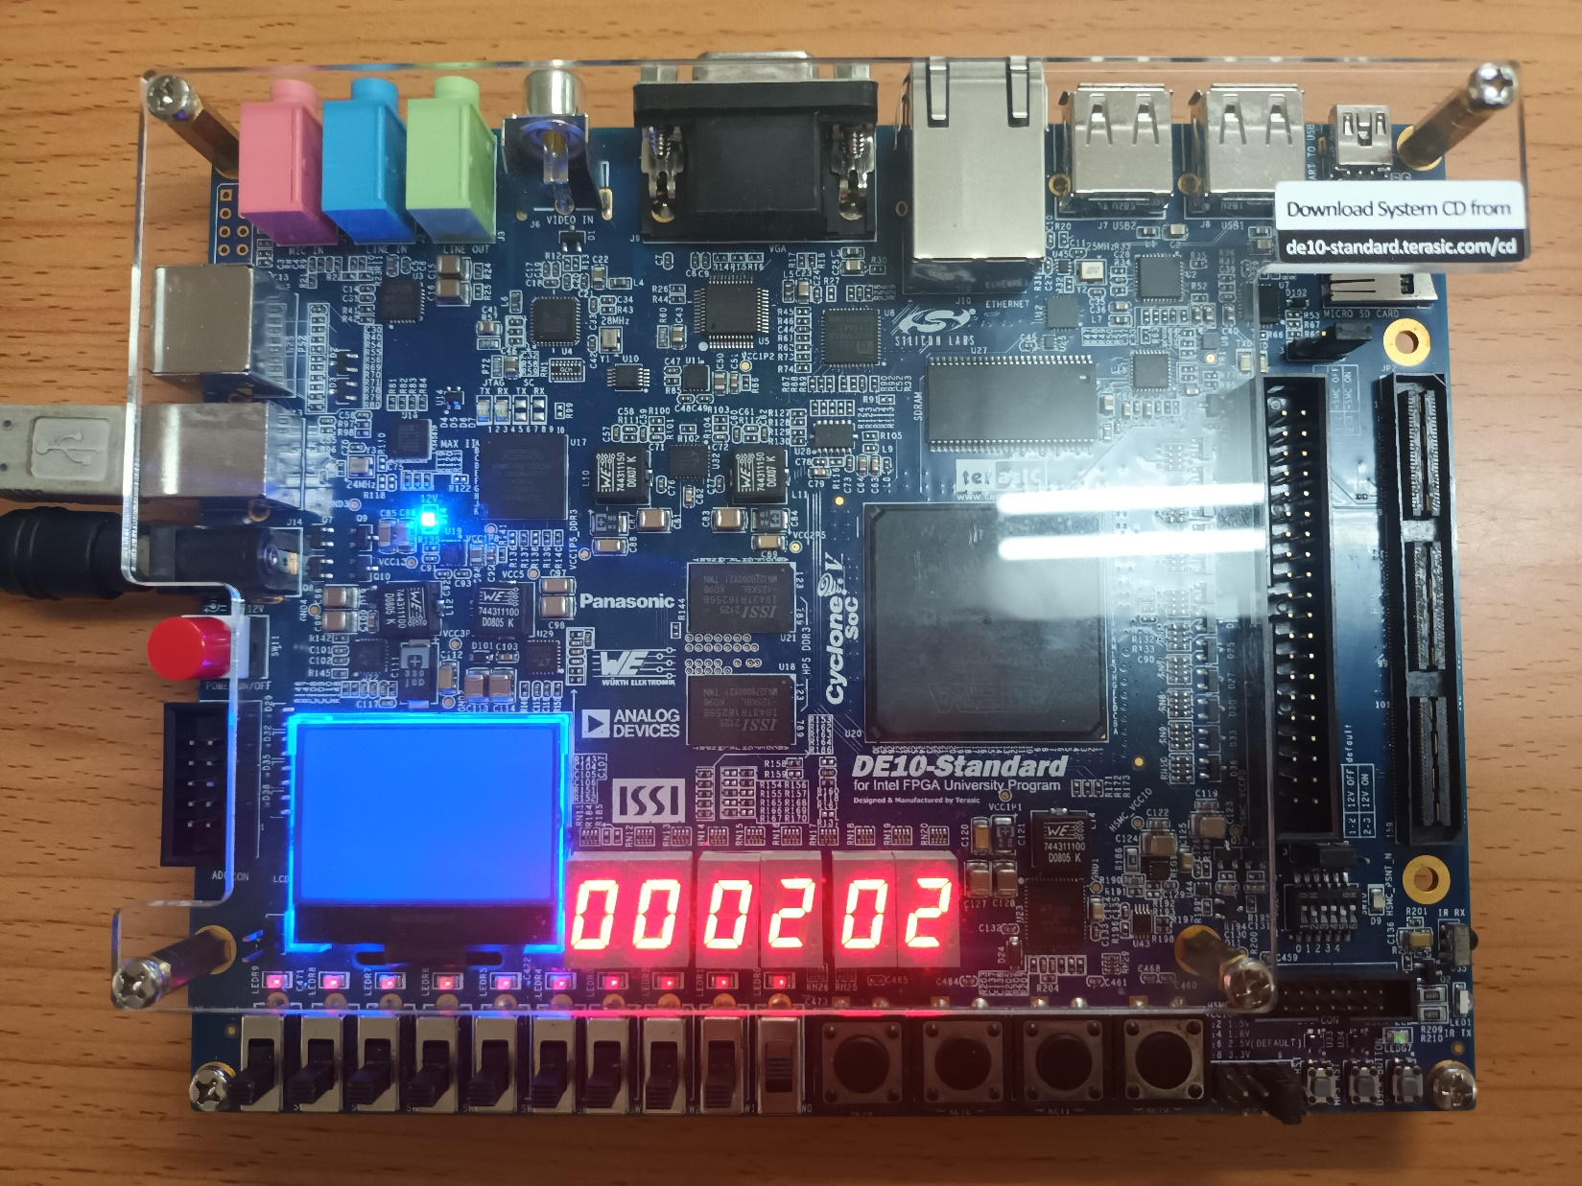  
*When SW0 is on, result is the same for all test cases: 514 (20216) cycles.*

*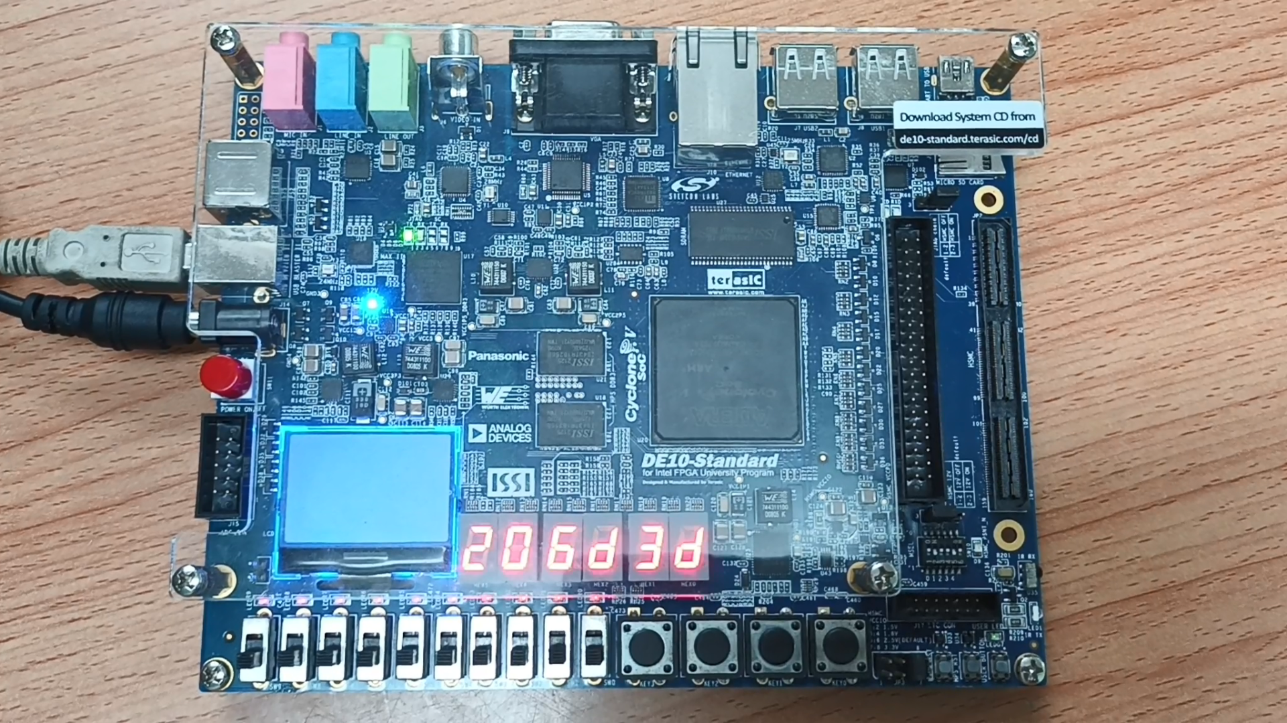  
Test Case #1 Passed*

*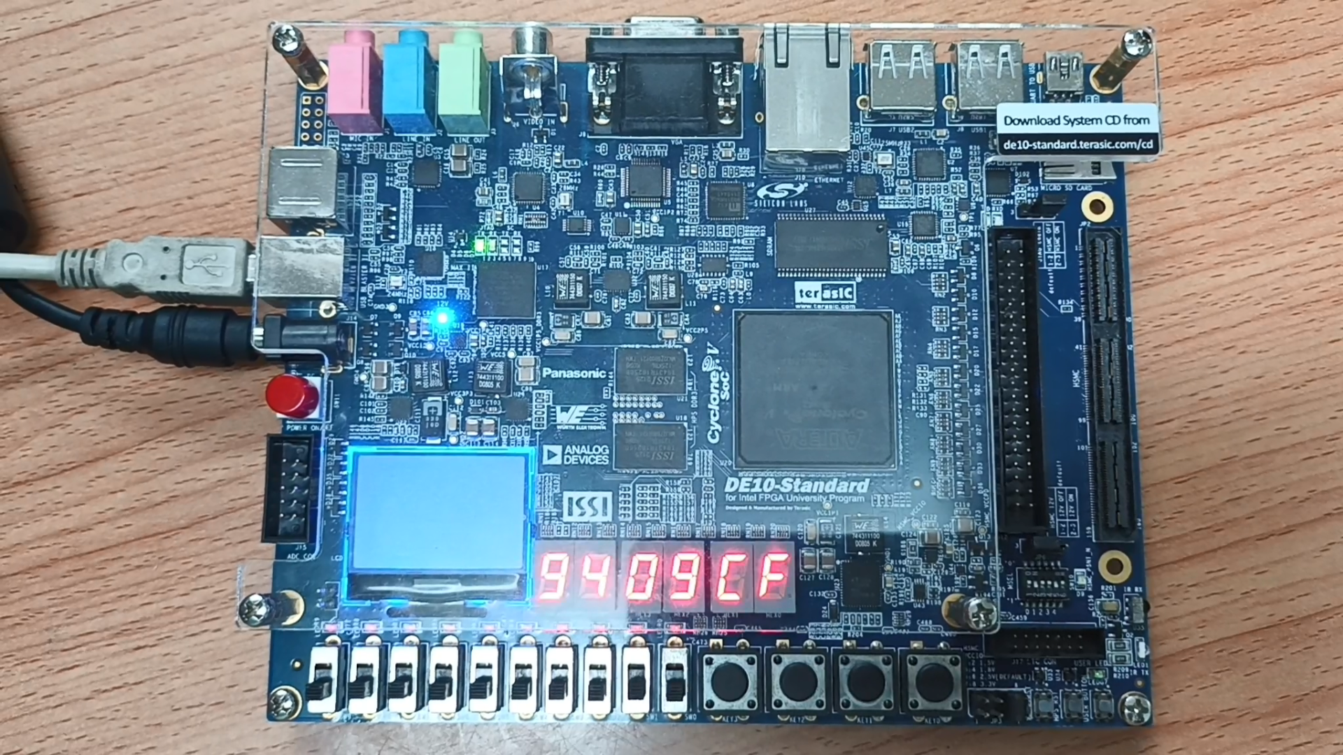  
Test Case #2 Passed*

*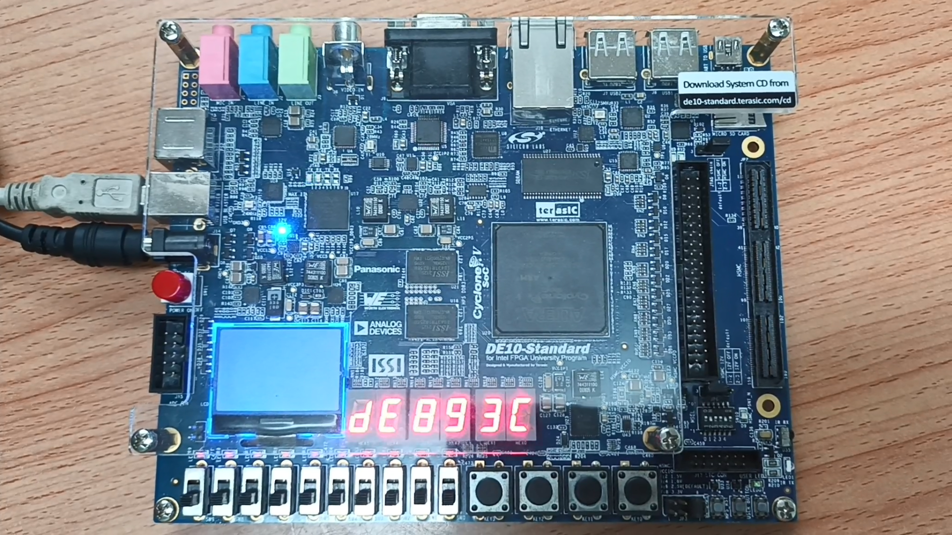  
Test Case #3 Passed*

*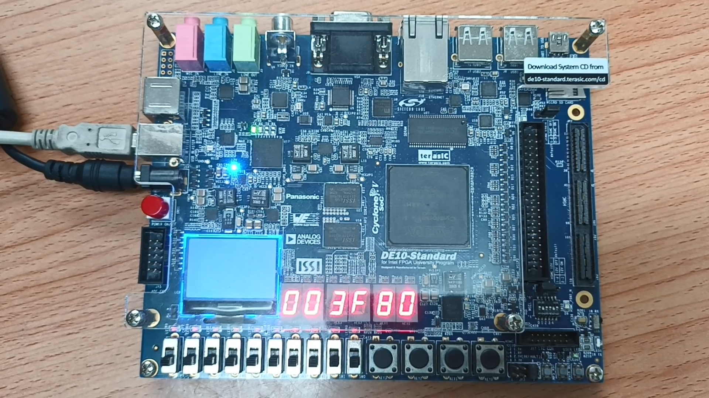  
Test Case Max Passed*